SUTD 50.001 Introduction to Information Systems and Programming
Problem Set 3A

For all questions, please access the vocareum link found at eDimension for the starter code and to submit.
The Vocareum link is for submission only. Please work on the problems in Android studio, and this includes writing code for the test cases.
To prevent hard-coding, test cases used in Vocareum may be different from those provided here and will not be given to you.

There is only one question in this Problem Set.

- [48 points] We modify an earlier question in Problem Set 1B to illustrate how object creation can delegated to another class and to show how you can apply good OOP design principles to make your code flexible.
Requirement 1. You are given an abstract class called Animal. It has one abstract method public String makeSound();

public abstract class Animal {
private String name;
Animal(String name){
this.name = name;
}
public String getName(){
return name;
}
public abstract String makeSound();
}

Add toString() method as a matter of good practice. Make it return the String returned by getName().

Add equals() and hashCode() methods as a matter of good practice.

UPDATE 10 Mar 2025.
equals() is meant to return true if the contents of two objects of the same class, this and other are the same, and false otherwise. In equals(), there should be code for:
- If this and other are the same object, return true
- If other is not an instance of Animal, return false, otherwise if the name instance variables are the same, return true, otherwise, return false

@Override
public final boolean equals(Object other) {
if( this == other) return true;
if( !( other instanceof Animal))return false;
Animal that = (Animal) other;
return getName().equals(that.getName());
}

hashCode() must also be overridden if equals() is overridden. Two objects that are equal have to return the same value for hashCode(). It is sufficient to use the static method Objects.hash() or the other code (which is generated by the Android studio code wizard).

Using the Android studio Wizard to generate equals() and hashCode() (2025)
In Android studio, just type in equals and select the “generate via wizard” option. Read the options carefully.
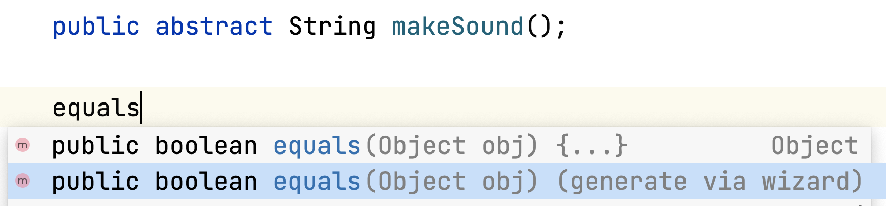

Then select the option as follows and click Next.
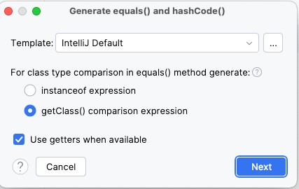
Note that the code for equals() may be different from the one given above but it would fulfill what the equals() method needs to do.

For more details, refer to this website. https://www.baeldung.com/java-equals-hashcode-contracts

Create three concrete classes Cat, Cow and Dog that are subclasses of Animal. Their constructors initialize the name field as illustrated below. Override makeSound() in the respective classes to return a String as illustrated below.

Constructor | getName() returns | makeSound() returns
new Cat(“Neko”) | Cat:Neko | Cat:Neko says Meow
new Dog(“Fido”) | Dog:Fido | Dog:Fido says Woof
new Cow(“Gyudon”) | Cow:Gyudon | Cow:Gyudon says Moo Moo

Requirement 2. You are given an interface AnimalFactory with one abstract method createAnimal(String type, String name).
This method is meant to take in two inputs
- type, which could be the Strings “Cat”, “Dog”, “Cow” or any other string
- name, which is a String to be passed to the constructor of Cat(), Dog() or Cow()
and return an Animal object. Such a design is sometimes called the “Simple Factory Pattern”.

Create a class FarmFactory which implements AnimalFactory. The following table summarizes how createAnimal() is to be implemented, based on the String contained in type.

If type is the following String (case-sensitive): | Then this method returns the following object:
“Cat” | new Cat(name)
“Dog” | new Dog(name)
“Cow” | new Cow(name)
Any other string | null

Requirement 3. You are given the class Zoo which has the following structure.

public class Zoo {
private AnimalFactory animalFactory;
private List<Animal> animalList;
Zoo(AnimalFactory animalFactory){
}
public void addAnimal(String type, String name){
}
public String performConcert(){
}
}

Complete the following.

- The constructor to initialize the instance variables. You are free to assign any List<E> concrete class to animalList.
- Override toString() to return the toString() of animalList

- public void addAnimal(String type, String name)

This invokes the createAnimal method on the abstractFactory instance variable which returns an Animal object based on the inputs type and name.
If this Animal object is not null, it is added to animalList, otherwise, nothing happens.

- public String performConcert()

This loops through animalList and returns a String which concatenates all the Strings returned by makeSound(), separated by an asterisk. There are no newline characters in the string returned.

Testcases are found in TestZoo.java and are reproduced below for your reference. TestZoo is provided in Vocareum for your convenience, and the test cases are not exhaustive. You are expected to test each class on your own.
public class TestZoo {
public static void main(String[] args) {
Animal cat1 = new Cat("ichika");
System.out.println(cat1.getName());
System.out.println(cat1.makeSound());
/** Output:
* Cat:ichika
* Cat:ichika says Meow */
Animal cat2 = new Cat("nino");
Animal cat3 = new Cat("ichika");
System.out.println(cat1.equals(cat3));
System.out.println(cat2.equals(cat3));
/** Output:
* true
* false */
Animal dog1 = new Dog("Fido");
System.out.println(dog1.getName());
System.out.println(dog1.makeSound());
/** Output
* Dog:Fido
* Dog:Fido says Woof
*/
AnimalFactory animalFactory = new FarmFactory();
Animal animal1
= animalFactory.createAnimal("Cat","miku");
Animal animal2
= animalFactory.createAnimal("Dog","hachiko");
System.out.println(animal1.getName());
System.out.println(animal2.getName());
/** Output
* Cat:miku
* Dog:hachiko */
Zoo zoo = new Zoo( new FarmFactory());
System.out.println(zoo);
zoo.addAnimal("Cat", "Kuroneko");
zoo.addAnimal("Dog", "Bond");
zoo.addAnimal("Cow", "Gyudon");
System.out.println(zoo.performConcert());
System.out.println(zoo);
/** Output
* []
* Cat:Kuroneko says Meow*Dog:Bond says Woof*Cow:Gyudon says Moo Moo*
* [Cat:Kuroneko, Dog:Bond, Cow:Gyudon]
*/
}

